Comprehensive Guide to Presentation: Network Traffic Analysis and Detection Using Data Mining

Project Definition
Title: Network Traffic Analysis and Detection Using Data Mining
Description: This project utilizes the KDDCup99 dataset to analyze and detect suspicious traffic and various types of network attacks. The primary goal is to discover traffic patterns and identify security threats using data mining algorithms. The approach incorporates advanced techniques such as data preprocessing, clustering, and classification.

Project Objectives
- Discovering Traffic Patterns: Identifying normal traffic patterns and distinguishing them from anomalous traffic.
- Predicting Types of Security Attacks: Designing and training a model to predict various types of security attacks with high accuracy.

Steps Taken
1. Data Preprocessing
- Data Cleaning:
  - Using the duplicate remove operator, the number of records was reduced to 145,584.
  - The id generate operator assigned a unique identifier to each data row.
- Feature Selection:
  - The weight by information gain and select by weights operators were used to identify and select the most important features.
- Normalization:
  - The normalize operator was employed to scale the data uniformly.
  - The Discretize operator was used to categorize continuous data into specific intervals.
2. Clustering Data Using DBS can Algorithm
- The clustering(DBScan) operator was used with the following parameters:
  - eps = 2.0: Radius of the neighborhood.
  - min points = 5: Minimum number of points required to form a cluster.
- The data was grouped into four distinct clusters.
3. Information Classification
- The C4.5 algorithm was used for data classification.
- The id3, data split, and model apply operators were utilized with the following parameters:
  - minimal size split = 4
  - information gain as the criterion.
4. Results Presentation
- Overall Model Accuracy:
  - The overall accuracy of the model was 95.65%, calculated using the performance operator.

Suggestions for Improvement
- Replacing the id3 algorithm with random forest could potentially increase the model's accuracy to nearly 100%.
- Expanding the training dataset to enhance model performance.
- Utilizing more advanced preprocessing techniques to reduce data noise.

Clustering and Process Charts
Clustering Chart:
- The clustering chart clearly illustrates four clusters identified by the DBScan algorithm. These clusters represent different traffic groups.
Process Chart:
- The workflow chart visualizes the stages of data preprocessing, clustering, and classification in detail.
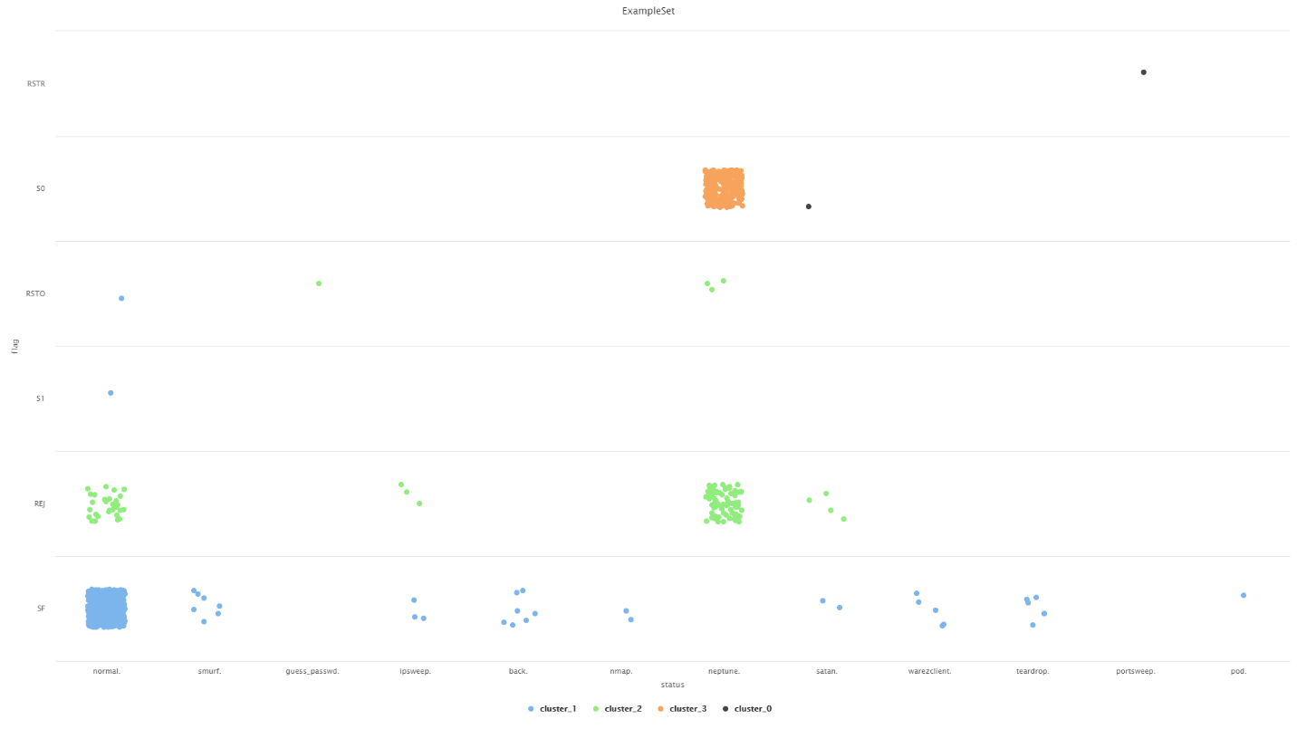
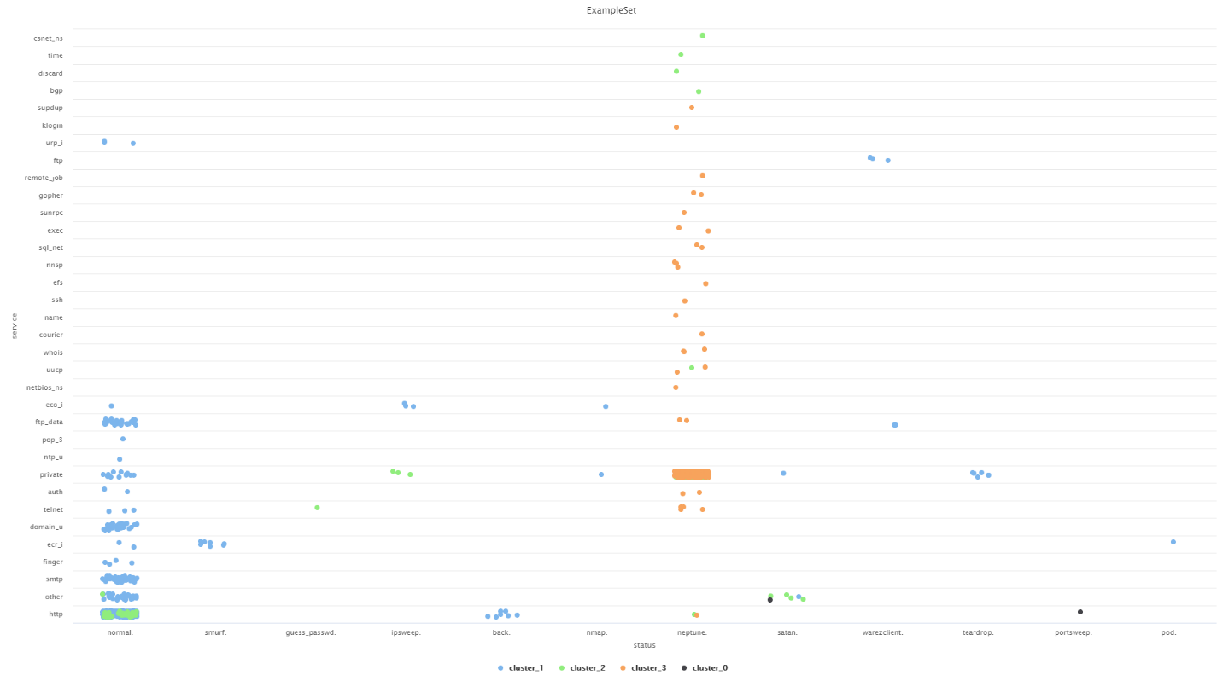
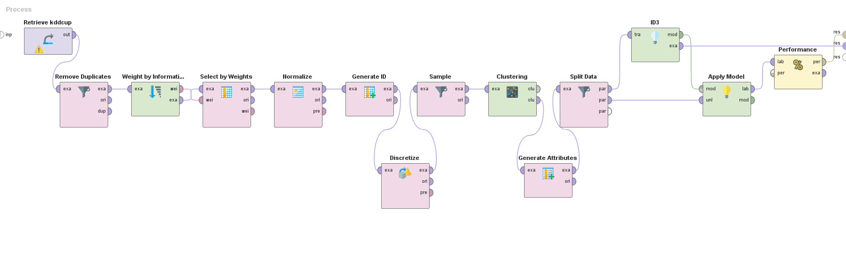

Attached Files
- The process file along with the results is attached for further reference.

Conclusion
This project successfully analyzed network traffic and identified security threats using advanced data mining algorithms. Employing enhanced techniques, such as random forest, could improve the model's accuracy and efficiency. Further research and the adoption of more sophisticated algorithms are recommended for continued progress in this field.

